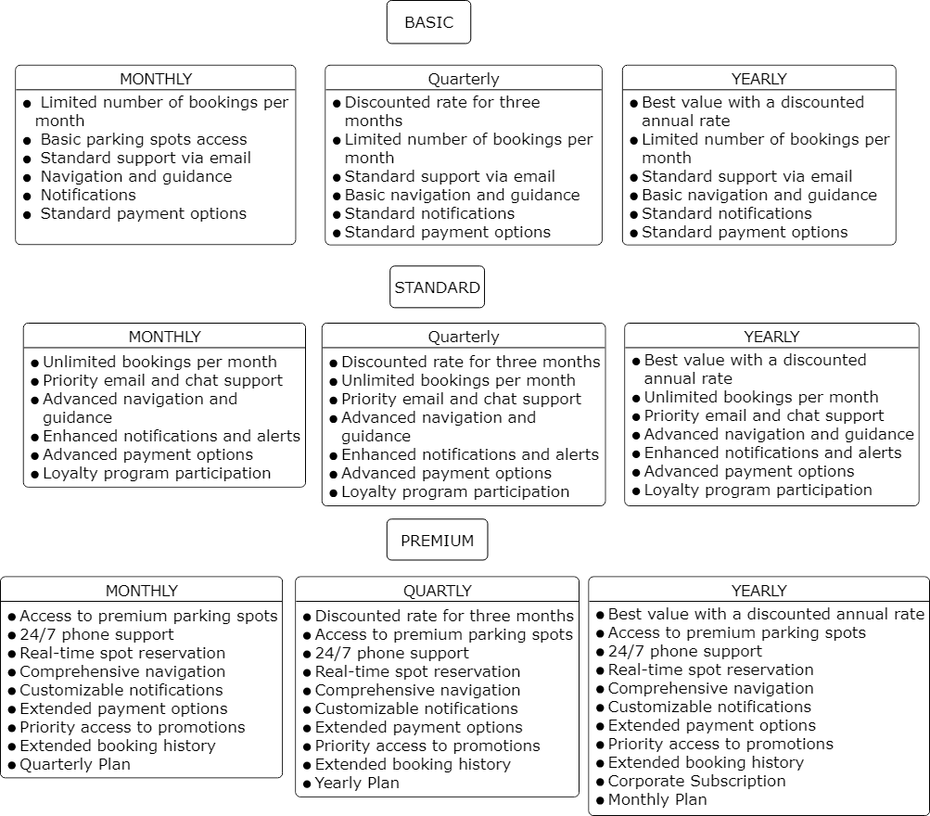

Basic Plan
- Monthly: Unlimited number of bookings per month. Email support. Two days advance bookings. Cost: 1800 (will differ with locations) 60
- Quarterly: offers, 6 additional free bookings on weekdays, Cost: 4500 50
- Yearly: bigger offers, 12 extra free bookings, Cost: 14600 40

Standard Plan
- Monthly: Unlimited bookings, priority email and chat support, same-day advance bookings, and 3 free additional bookings. Cost: ₹2700 (varies by location). 90
- Quarterly: Includes all monthly benefits, additional 10 free bookings Cost: ₹7200. 80
- Yearly: Includes all quarterly benefits, additional 24 extra free bookings Cost: ₹25550. 70

Premium Plan
- Monthly: Unlimited bookings, 24/7 premium support, immediate advance bookings Cost: ₹3000 (varies by location). 10
- Quarterly: Includes all monthly benefits plus 20 extra free Cost: ₹13500. 150
- Yearly: Includes all quarterly benefits plus 30 (1 month) free bookings. Cost: ₹73000. 200

